Mapping Template

Canadian Quality and Patient Safety Framework for Health Services
Use this template to map your current quality and patient safety improvement initiatives to the goals, objectives, and outcomes of the Framework. When you are done, please consider emailing qualityservicesforall@healthstandards.org and share your experience using the Framework to help inspire others to align Canada on five goals for quality, safe care.

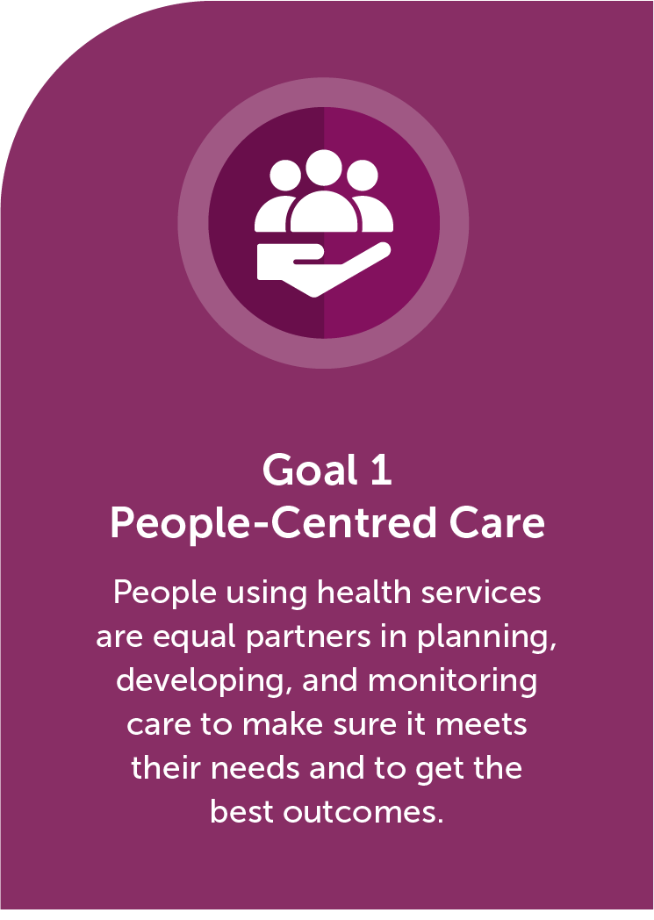 |  | Objectives |  | Outcomes | Your Initiatives
 | 1.1 | Health services are provided with humility in a holistic, dignified, and respectful manner.  Indicator: Patients’ ratings of the extent to which care was provided with respect | 1.1.1 | Patients make informed contributions and decisions related to their care and treatment. | Examples include, but are not limited to, advocacy, wise practices, training, programs, accreditation activities, committees, frameworks, partnerships, policies, regulations, and acts.
 |  |  | 1.1.2 | Diverse peoples, including  First Nations, Inuit, Metis, Black, LGBTQ2S+, immigrant, and people in rural and remote communities receive care that is culturally safe.
 | 1.2 | All aspects of care are  co-designed with patients  and providers.  Indicator: Patient and provider involvement in care planning, governance, and evaluation (e.g., patient advisors) | 1.2.1 | Formal and informal patient partnerships are established  and consistently supported  at all levels.
 | 1.3 | Patients and providers have positive health service experiences.  Indicator: Patients’ overall ratings of health service experiences  Indicator: Providers’ overall rating of health service experiences | 1.3.1 | Patient-reported experience measures (PREMs) and patient-reported outcome measures (PROMs) are collected and reported and demonstrate improvements in experiences and outcomes.
 |  |  | 1.3.2 | Patients, regardless of background and circumstance, are engaged and report health service experiences.
 |  |  | 1.3.3 | Providers are engaged, report and learn from health service experiences.

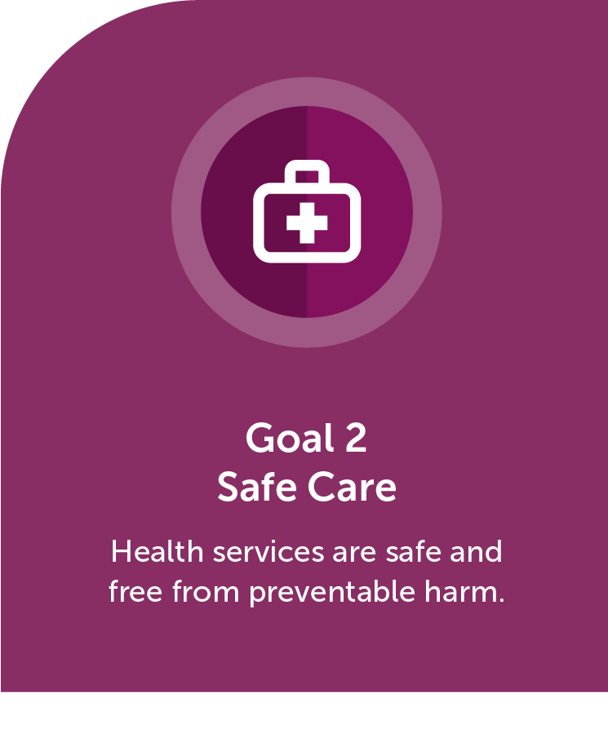 |  | Objectives |  | Outcomes | Your Initiatives
 | 2.1 | Safety culture is evident across the continuum of health services.  Indicator: Assessment of organizational efforts to monitor, review, and address patient safety incidents  Indicator: Training on quality improvement and patient safety provided at all organizational levels | 2.1.1 | Patients, providers and leaders are encouraged and supported to report and act on patient safety concerns and incidents.
 |  |  | 2.1.2 | Patient harm events are disclosed to the patient and/or family as soon as known and documented according to organizational policies.
 |  |  | 2.1.3 | Patient safety events are analyzed and acted upon by interdisciplinary teams which include patients.
 |  |  | 2.1.4 | Patients who are harmed have access to psychological support programs.
 |  |  | 2.1.5 | Providers work in psychologically and physically safe environments, with access to psychological support programs.
 | 2.2 | Safe and effective care is provided and monitored.  Indicator: Rate of avoidable deaths (in and outside the hospital setting)  Indicator: Rate of patient harm events | 2.2.1 | Evidence-based practices are implemented.
 |  |  | 2.2.2 | Provider practices are reviewed and outcome trends are reported to proactively drive safe practices.
 | 2.3 | Safe care is addressed as a public health concern.  Indicator: Rates of patient harm events and avoidable hospital readmissions are reported publicly | 2.3.1 | Health service organizations actively participate in an accreditation process.
 |  |  | 2.3.2 | Rates of patient harm and other indicators that reflect organizational safety are reported publicly.

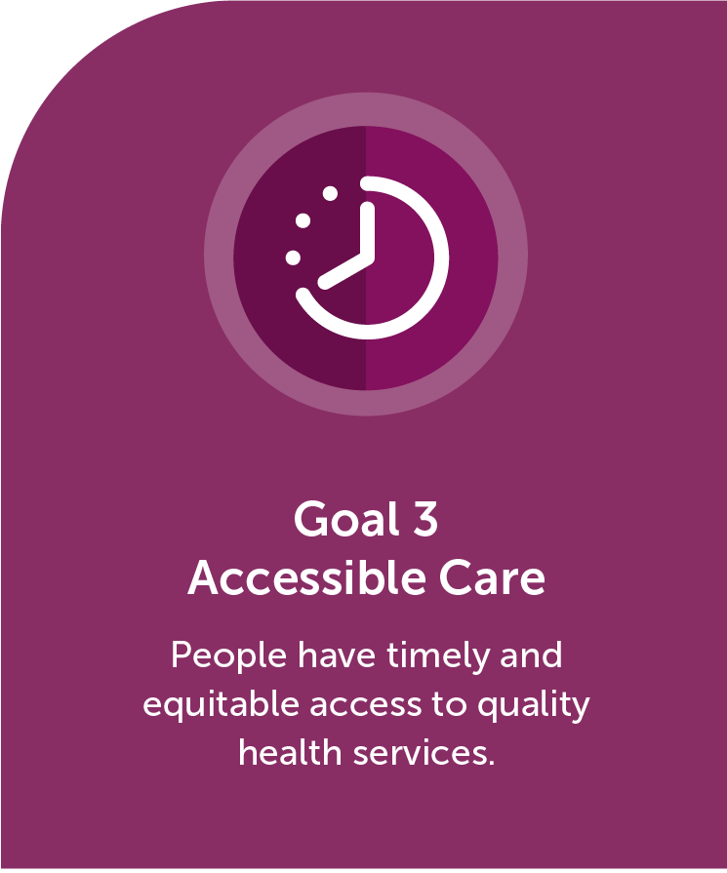 |  | Objectives |  | Outcomes | Your Initiatives
 | 3.1 | Care, diagnostics, and services are accessible for all people in an equitable and timely manner.  Indicator: Wait times for locally selected care, treatments, and procedures, analyzed by socio-demographic variables, geographic variables, and/or deprivation indices  Indicator: Rate of access to primary care provider, analyzed by socio-demographic variables, geographic variables, and/or deprivation indices | 3.1.1 | Diverse peoples, including First Nations, Inuit, Metis, Black, LGBTQ2S+, immigrant, and people in rural and remote communities, receive safe, equitable, and timely care.
 |  |  | 3.1.2 | Targets for access to services are measured and publicly reported.
 |  |  | 3.1.3 | Alternative options for care delivery are available, including virtual and in-person visits with a provider.
 | 3.2 | Human resources are effectively matched to population needs.  Indicator: Provider skill mix, given health service guidelines and needs of the population served | 3.2.1 | A needs-based human resource allocation strategy is in place, including an appropriate skill mix for the workforce.
 |  |  | 3.2.2 | The scope of practice of health service providers (both regulated and unregulated, knowledge keepers and Elders) is recognized and optimized based on evidence.

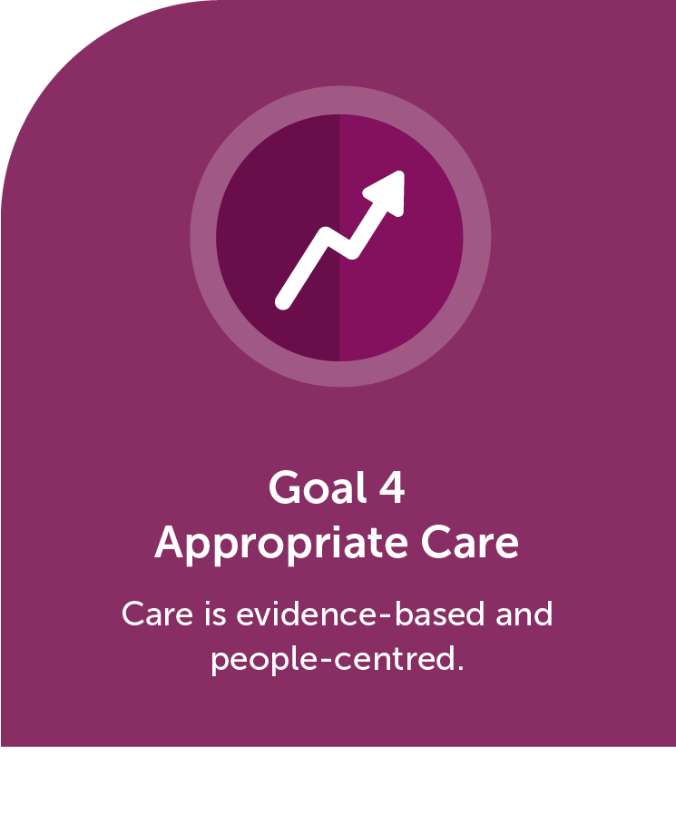 |  | Objectives |  | Outcomes | Your Initiatives
 | 4.1 | Health services are planned and delivered based on the needs of the population.  Indicator: Health services based on needs assessment | 4.1.1 | There is evidence that health promotion and disease prevention are addressed.
 | 4.2 | Appropriate care is actively promoted and monitored, and unwarranted variations are minimized.  Indicator: Variations in appropriate care, for locally selected interventions, are documented and inform quality improvement processes | 4.2.1 | Evidence-based care is demonstrated throughout the patient journey, reflecting patient preferences.
 |  |  | 4.2.2 | Unwarranted care variations are minimized.
 | 4.3 | Emerging treatments and technologies are systematically evaluated and implemented in health services.  Indicator: Implementation of health service innovation includes risk management, training, and evaluation to meet patient needs | 4.3.1 | Treatments, technologies, medical devices, and equipment are evaluated and monitored for appropriate use.
 |  |  | 4.3.2 | Health teams are prepared for effective use of new treatments and technologies.

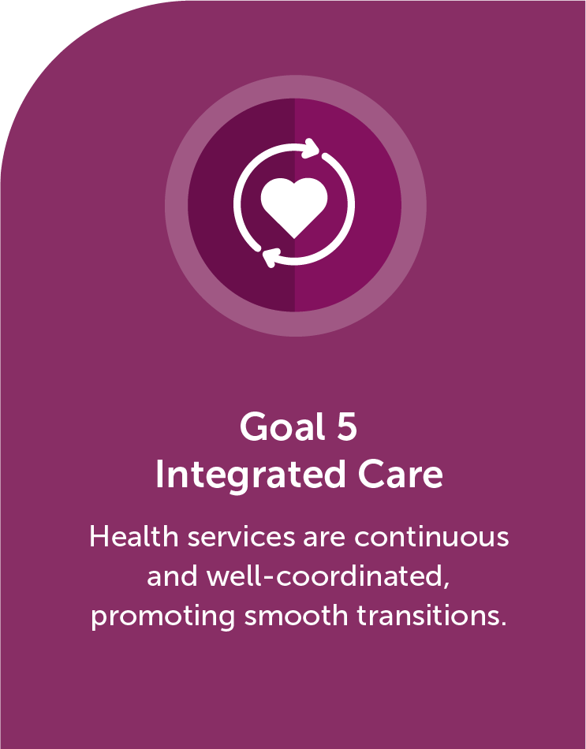 |  | Objectives |  | Outcomes | Your Initiatives
 | 5.1 | Patients experience smooth transitions across health services.  Indicator: Communication between primary care providers and specialists | 5.1.1 | The infrastructure and accountability for care transitions are in place.
 |  |  | 5.1.2 | Providers coordinate care across health services.
 | 5.2 | Patient information is available to patients and providers across health services.  Indicator: Prevalence of electronic communication  with patients  Indicator: Prevalence of integrated electronic health records | 5.2.1 | Providers have appropriate access to integrated electronic health records.
 |  |  | 5.2.2 | Patients have easy and timely access to their health information.

Other quality and patient safety initiatives
Please consider emailing qualityservicesforall@healthstandards.org and share your experience using the Framework to help inspire others to align Canada on five goals for quality, safe care. Thank you!

